Interface View :

@AbapCatalog.viewEnhancementCategory: [#PROJECTION_LIST]

@AccessControl.authorizationCheck: #NOT_REQUIRED

@EndUserText.label: 'Basic or Interface View for flight'

@Metadata.ignorePropagatedAnnotations: true

@ObjectModel.usageType:{

serviceQuality: #X,

sizeCategory: #S,

dataClass: #MIXED

}

**define** **root** **view** **entity** ZAKP_I_FLIGHT **as** **select** **from** /dmo/flight

**{**

**key** carrier_id **as** CarrierId**,**

**key** connection_id **as** ConnectionId**,**

**key** flight_date **as** FlightDate**,**

@Semantics.amount.currencyCode: 'CurrencyCode'

price **as** Price**,**

currency_code **as** CurrencyCode**,**

plane_type_id **as** PlaneTypeId**,**

seats_max **as** SeatsMax**,**

seats_occupied **as** SeatsOccupied

**}**

Consumption View:

@EndUserText.label: 'Projection Concumption View'

@AccessControl.authorizationCheck: #NOT_REQUIRED

@Search.searchable: true

@UI.headerInfo: {

typeName: 'Flight',

typeNamePlural: 'Flights',

title: {

type: #STANDARD,

label: 'Flights',

value: 'FlightDate'

}

}

**define** **root** **view** **entity** ZAKP_C_FLIGHT

**provider** **contract** **transactional_query**

**as** **projection** **on** ZAKP_I_FLIGHT

**{**

@UI.facet: [{

id: 'Flight',

purpose: #STANDARD,

position: 10,

label: 'Flights',

type: #IDENTIFICATION_REFERENCE

}]

@UI.identification: [{ position: 10 }]

@UI.lineItem: [{ position: 10 }]

@UI.selectionField: [{ element: 'CarrierId' }]

@Search.defaultSearchElement: true

**key** CarrierId**,**

@UI.identification: [{ position: 11 }]

@UI.lineItem: [{ position: 11 }]

@UI.selectionField: [{ element: 'ConnectionId' }]

@Search.defaultSearchElement: true

**key** ConnectionId**,**

@UI.identification: [{ position: 12 }]

@UI.lineItem: [{ position: 12 }]

@Search.defaultSearchElement: true

**key** FlightDate**,**

@UI.identification: [{ position: 13 }]

@UI.lineItem: [{ position: 13 }]

@Semantics.amount.currencyCode: 'CurrencyCode'

Price**,**

@UI.identification: [{ position: 14 }]

@UI.lineItem: [{ position: 14 }]

CurrencyCode**,**

@UI.identification: [{ position: 15 }]

@UI.lineItem: [{ position: 15 }]

SeatsMax**,**

@UI.identification: [{ position: 16 }]

@UI.lineItem: [{ position: 16 }]

SeatsOccupied**,**

@UI.identification: [{ position: 17 , label: 'Seats_left'}]

@UI.lineItem: [{ position: 17 , label: 'Seats_left'}]

@ObjectModel.virtualElementCalculatedBy: 'ABAP:ZCL_CODE_EXIT_CDS'

**virtual** left_seats **:** */dmo/plane_seats_max*

**}**

Class Implementation:

CLASS zcl_code_exit_cds DEFINITION

**PUBLIC**

FINAL

CREATE **PUBLIC** .

**PUBLIC** SECTION.

INTERFACES if_sadl_exit_calc_element_read.

**PROTECTED** SECTION.

**PRIVATE** SECTION.

ENDCLASS.

CLASS zcl_code_exit_cds IMPLEMENTATION.

**METHOD** if_sadl_exit_calc_element_read~calculate.

DATA lt_original_data TYPE STANDARD TABLE OF zakp_c_flight WITH DEFAULT KEY.

lt_original_data = CORRESPONDING #( it_original_data ).

LOOP AT lt_original_data ASSIGNING FIELD-SYMBOL(<lfs_original_data>).

<lfs_original_data>-left_seats = <lfs_original_data>-SeatsMax - <lfs_original_data>-SeatsOccupied.

ENDLOOP.

ct_calculated_data = CORRESPONDING #( lt_original_data ).

**ENDMETHOD**.

**METHOD** if_sadl_exit_calc_element_read~get_calculation_info.

**ENDMETHOD.**

ENDCLASS.

Service Definition:

@EndUserText.label: 'Service Definition for Flight'

**define** **service** ZUI_AKP_FLIGHT **{**

**expose** ZAKP_C_FLIGHT**;**

**}**

Service Implementation:

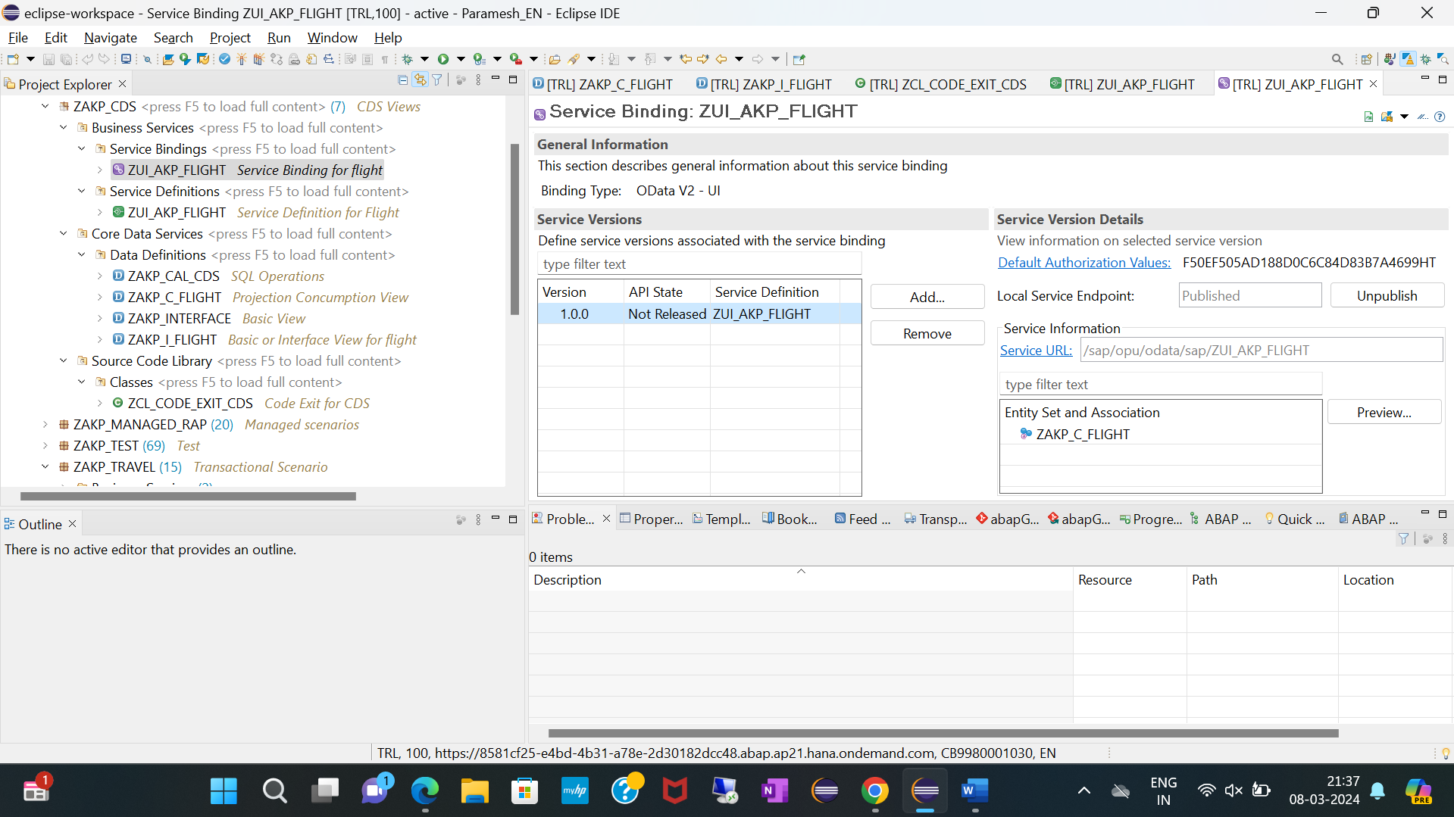

Report:

